The progress report on age and growth of striped marlin (Kajikia audax) in the western North Pacific Ocean

Ayumu Furuyama¹, Miwako Funabara¹, Yuichi Arai¹, Yuki Ishihara², Mikihiko Kai², and Minoru Kanaiwa¹

¹Faculty of Bioresources, Mie University, Mie, Japan
² Fisheries Resources Institute (FRI), Highly Migratory Resources Division,
Japan Fisheries Research and Education Agency, Yokohama, Japan

Email: furuyama@bio.mie-u.ac.jp

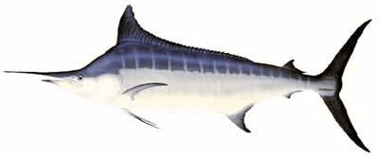

Abstract
Growth parameters are essential for fish stock assessment. Previous studies suggested that striped marlin (Kajikia audax) in the western North Pacific (Sun et al. 2011) grow more slowly than those in the South Pacific (Kope et al. 2011). However, Sun et al. (2011) did not confirm the first-year annulus in spines using objective data. In this study, we re-evaluated the age and growth of striped marlin in the western North Pacific by defining the first-year annulus on fin-spine sections, based on the estimated eye-to-fork length (EFL) at 365 days derived from otolith daily increments. Among 452 specimens collected between 2020 and 2024, daily ages were successfully estimated for 75 otoliths, yielding a 365-day EFL of 135.6 cm (95% PI: 112.7–163.0 cm). This range was applied to identify the first annulus in spine cross-sections. The resulting growth curves indicated faster growth than previously reported for the same region by Sun et al. (2011), suggesting that earlier studies may have misidentified false early annuli as true annuli. Compared with the South Pacific population (Kopf et al. 2011), striped marlin in the western North Pacific exhibited slower growth, with lower L∞ and older ages at 0.9L∞. Early growth based on otolith increments was similar across eastern North Pacific and Southwest Pacific, implying that regional differences emerge after the juvenile stage. Further work will incorporate remaining samples and extend age estimation to central and eastern Pacific populations to clarify basin-scale variation in growth.

Introduction
Growth parameters are essential for fish stock assessment. The age and growth of striped marlin (Kajikia audax) in the Pacific Ocean have been investigated in the Southwest Pacific (Kopf et al. 2011) and the western North Pacific (Sun et al. 2011), and these studies suggested that striped marlin in the western North Pacific grow more slowly than those in the Southwest Pacific. However, fin-spine sections of striped marlin are known to contain numerous false annuli (Kopf and Davie 2011), raising concerns that growth curves may vary substantially depending on the annulus-reading method employed. Based on Furuyama et al. (2024), which compared otolith daily increments with spine rings diameters, Sun et al. (2011) may have misinterpreted false annuli as true annuli, potentially underestimating growth rates.
In this study, we estimated the age and growth parameters of striped marlin in the western North Pacific by defining the one-year annulus on spine sections using the estimated eye-to-fork length (EFL) at 365 days of age.

Methods
Sample collection
Between May 2020 and February 2024, otoliths (n=103) and dorsal fin spines (n=416) were collected from 452 striped marlin individuals caught in the western North Pacific (Table 1). For each specimen, the EFL was measured, and sex was determined based on the gonadal examination.
Preparation of Otolith Cross-sections
Right or left otoliths were embedded in epoxy resin (Epoxy Resin Type 53, Sankei Co. Ltd.) poured into silicone-sprayed cases (Kure Polymate Natural, Kure Engineering Ltd.), with the concave side facing upward. After curing for 24–48 h, the embedded otoliths were sectioned through the core using a low-speed saw (Isomet Low Speed Saw, BUEHLER).
The resulting sections were cleaned and mounted on glass slides with Crystal Bond 509 (Alemco), then polished using a polishing machine (MARUTO Trap ML-110NT, MARUTO) until the nucleus was clearly visible. Polishing was performed with polishing paper (#800, MARUTO) and polishing cloth (Touch Lam 2TS4, Musashino Electronics) in combination with alumina powder (Baikalox, Baikowski).
Polished sections were photographed under a biological microscope (BX53, OLYMPUS) equipped with a 100× objective lens, and images were captured using ScopeImage 9.0 (AS ONE Corporation). Sequential images from the core to the ventral edge were merged based on otolith contours in Photoshop 2024 (Adobe), and the final composite images were exported as PNG files.
Daily age estimation
Daily increments were counted on the merged otolith images using Image J (Abramoff et al. 2004). Rings were traced from the core to the ventral edge; when increments near the core were unclear, counting began at the first visible ring (Fig. 1), and unreadable rings were verified directly under the microscope. A single continuous dark band was counted as one daily increment, even if partially merged or interrupted. Otoliths with inflected or indistinct growth rings at the edges were excluded from the analysis. Daily increment counts were performed independently by three readers, and after confirming no substantial discrepancies among readers, the median value was adopted as the estimated daily age.
Preparation of spine cross-sections
Excess tissue was removed from the base of the fins, and a slit was made in the fin membrane. Fins with sample tags were boiled for several minutes. After boiling, the spines were detached from the radial cartilages. If separation was difficult, additional boiling for 2 minutes was performed. The first to third longest spines were collected, while the others were discarded. The collected spines were threaded with wire through the condyle hole when possible and boiled again for a few minutes. Residual soft tissue was removed using a scrubbing brush, and the spines were air-dried.
For age estimation, the longest spine was used. The maximum condyle width (CW) was measured, and a cutting line was marked at a distance equal to one-half of the CW from the condyle toward the spine tip. The spine was mounted on a low-speed saw (Isomet Low Speed Saw, BUEHLER) so that the blade intersected the cutting line. The micrometer was advanced approximately 30–35 scale units to initiate cutting, starting at speed 2 and gradually increasing to speed 6. After cutting, the micrometer was moved back 60–70 scale units to obtain sections of suitable thickness.
The cut sections were cleaned and mounted on glass slides using Crystal Bond 509 (Alemco) melted on a hot plate (Ceramic Hot Plate, AS ONE) at >100°C. After cooling and hardening, the surface was polished using a polishing machine (MARUTO Trap ML-110NT, MARUTO) with polishing paper (#800, MARUTO), polishing cloth (Touch Lam 2TS4, Musashino Electronics), and alumina powder (Baikalox, Baikowski) until clear growth rings were visible.
Polished spine sections were photographed under a stereomicroscope (EZ4D, Leica) equipped with an 8× objective lens and LAS EZ 3.4.0 software (Leica) at a resolution of 2048 × 1536 pixels. When the entire cross-section could not be captured in a single image, two overlapping images were taken and merged using MosaicJ (a plug-in for ImageJ). The merged images were saved in JPG format.
Age estimation in spine section
Photographs of spine cross-sections were imported into ImageJ. Unbroken translucent zones from top to bottom in each spine section were counted as annuli. The spacing between translucent zones was used to identify false annuli. The pixel length of the spine’s long diameter and each annulus was measured using the measurement tool. The estimated EFL at the time of each ring formation was calculated by back-calculation based on the following equation of relationship between spine diameter and EFL in 211 individuals:
ln (EFL) = 0.5999 ln (spine diameter) + 3.7140.
Because false annual rings frequently appear during early growth stages of marlins, the first-year ring was identified using the 365-day EFL and its 95% prediction interval estimated from otolith daily age. Annuli counts were performed independently by two readers.
The Marginal increment ratio (MRI) was calculated according to the following equation:
MIR=(SD-d_{n})/(d_{n}-d_{n–1}),
where SD, d_{n}, and d_{n-1} represent the diameter of spine section, the last annulus, and the penultimate annulus, respectively.
Statistical analysis
Because the central portion of spine sections can be lost as the fish grows, the first annulus on a spine was corrected when its diameter exceeded the upper limit of the 95% prediction interval for the diameter of the first annulus in the smaller individuals than the mean EFL at two years old in previous report(<175 cm EFL; Furuyama et al. 2024). In such cases, the diameter of the first annulus for that individual was compared with the mean annulus diameters of small fish up to age 4, and the corresponding number of years was added to adjust the estimated age.
Based on the age estimates derived from spine sections, the von Bertalanffy growth curve was fitted. Two types of models were constructed for growth estimation: one using observed EFL and age (normal model), and another based on back-calculated EFL. The normal model also incorporated age estimates obtained from otolith daily increments. In addition, both sex-specific and combined-sex models were developed. Total AIC (Akaike 1973) of male and female models and AIC of combined-sex model without unknown sex samples were compared for comparison of model performance.

Results
Of the 103 otoliths, 75 were suitable for daily age estimation (Fig. 2). No substantial discrepancies greater than six months were observed, and no systematic bias was detected (Fig. 3); therefore, the median value was adopted as the estimated daily age. The relationship between daily age and eye-to-fork length (EFL) for these 75 individuals is shown in Fig. 4. The estimated EFL at 365 days was 135.57 cm, with a 95% prediction interval of 112.74–163.03 cm. Striped marlin in the western North Pacific exhibited early growth patterns similar to those observed in the eastern North Pacific (Shimose and Yokawa 2019) and the Southwest Pacific (Kopf et al. 2011).
Based on the 365-day estimated EFL and 95% prediction interval from otolith results, the first-year annulus on spine sections was assumed to form at ≥112.74 cm, and spine-based age estimation was conducted. Reader 1 and Reader 2 independently aged the spines of 211 and 213 individuals, respectively. Cross-reading results for the 171 individuals common to both readers are presented in Table 2. Reader 2 tended to count more annuli at younger ages, whereas Reader 1 tended to count more at older ages. To evaluate this, the back-calculated EFL of the first annulus for spines identified as age-1 by each reader was compared with the back-calculated EFL of the outermost annulus in individuals with otolith daily increments ≥350 days and <350 days (Fig. 5). The results indicated that the back-calculated EFL of Reader 2’s age-1 annuli were smaller than that of the outermost annulus in individuals >350 days, suggesting that false early annuli may have been counted in smaller individuals. Therefore, age estimates from Reader 1 were adopted for subsequent analyses.
The relationship between back-calculated EFL and age for each individual, as well as the corresponding growth curves, are shown in Fig. 6. Males were observed up to age 6, while females were observed up to age 8. When comparing sex-specific and combined-sex growth models based on back-calculated EFL, the sex-specific model showed lower AIC values (Table 3). Females tended to reach larger maximum EFLs than males.
Monthly MIR observations revealed low MIR values in January, February, April, and May, while high MIR values exceeding 0.75 were also observed in January and February (Fig. 7). This suggests that annulus formation may occur twice. However, a two-month moving average (current month and previous month) indicated the lowest MIRs between May and July, suggesting that annulus formation predominantly occurs from spring to early summer. For subsequent analyses, monthly age increments were added based on the capture month, using July—the starting month for stock assessment simulations (SS3)—as a reference.
Growth curve estimation using observed age and EFL also indicated that females tended to attain larger sizes than males, although the sex difference was smaller than that observed in the back-calculated EFL model (Fig. 8). In this case, the combined-sex model had lower AIC values (Table 3). The sexual differences in growth patterns of striped marlin in the western North Pacific require careful further investigation.
Estimated EFLs by age from growth curves based on annulus counts and measured EFL are presented in Table 4. Fig. 9 compares the growth curves obtained in this study with those from previous studies. Compared with Sun et al. (2011), who also estimated growth curves for western North Pacific striped marlin, both the normal model and the back-calculated EFL model in this study predicted faster growth. Sun et al. (2011) may have counted false annuli in pre-age-1 individuals, whereas our 365-day EFL validation supports the reliability of the current results.
When comparing growth in the western North Pacific with that in the Southwest Pacific (Kopf et al. 2011), the L∞ values were as follows: females, 217.32 cm in Kopf et al. (2011) and 205.36 cm in this study: males, 206.61 cm in Kopf et al. (2011) and 194.74 cm in this study. The age at 0.9L∞ was 3.14 years for females and 2.68 years for males in Kopf et al. (2011), versus 4.43 and 3.85 years in this study, indicating slower growth rates for both sexes in the western North Pacific. Early growth based on otolith daily increments showed similar patterns to Kopf et al. (2011), suggesting that growth differences arise later. Potential factors contributing to growth variation include density effects, nutritional status, and genetic traits, but these remain undetermined.
Future work will complete age estimation for remaining western Pacific striped marlin and initiate age estimation for populations in the central and eastern Pacific.

References
Abramoff, M. D., Magelhaes, P. J. and Ram, S. J. 2004. Image Processing with ImageJ. Biophotonics International, 1 1(7): 36-42.
Akaike, H. (1973) Information theory and an extension of the maximum likelihood principle. In: Csáki, F., Petrov, B. N. (eds.), 2nd International Symposium on Information Theory. Akadémiai Kiadó, Budapest, pp. 199– 213.
Furuyama, A., Funabara, M., Arai, Y., Ishihara, Y., Kai, M. and Kanaiwa, M. (2024). The progress of age estimation for striped marlin in the North Pacific. In Report of the ISC Billfish Working Group Workshop, Annex 9 (SC20-SA-WP-13): pp. 3.
Kopf, R. K. and P. S. Davie (2011) Fin-Spine Selection and Section Level Influence Potential Age Estimates of Striped Marlin (Kajikia audax). Copeia, 2011: 153-160.
Kopf, R. K., P. S. Davie, D. Bromhead, and J. G. Pepperell (2011) Age and growth of striped marlin (Kajikia audax) in the Southwest Pacific Ocean. ICES Journal of Marine Science, 68(9): 1884-1895.
Shimose, T. and K. Yokawa (2019) Age estimation of striped marlin (Kajikia audax) in the eastern North Pacific using otolith microincrements and fin spine sections. Marine and Freshwater Research, 70: 1789-1793.
Sun, C., W. Hsu, N. Su, S, Yeh, Y. Chang, Wei-Chuan Chiang (2011) Age and growth of striped marlin (Kajikia audax) in waters off Taiwan: A revision. The Intercessional Workshop of the Billfish Working Group of the International Scientific Committee for Tuna and Tuna-like Species in the North Pacific Ocean (ISC). 24 May-1 June 2011. Taipei, Taiwan. ISC/11/BILL WG-2/07, 12 pp.

Tables
Table 1 Summary of specimens collected and those included in the statistical analysis (number in parentheses).
Sex | Number of specimens
 | Otolith | Spine
Female | 59 (34) | 205 (104)
Male | 41 (28) | 192 (98)
Unknown | 25 (13) | 19 (9)
Total | 125 (75) | 416 (211)

 |  | Number of individuals for each annual ring in reader 1
 |  | 0 | 1 | 2 | 3 | 4 | 5 | 6 | 7 | 8
Number of individuals for each annual ring in reader 2 | 0 | 10 | 1 | 0 | 0 | 0 | 0 | 0 | 0 | 0
 | 1 | 0 | 14 | 1 | 1 | 0 | 0 | 0 | 0 | 0
 | 2 | 0 | 14 | 13 | 4 | 1 | 0 | 0 | 0 | 0
 | 3 | 0 | 2 | 23 | 30 | 7 | 0 | 0 | 0 | 0
 | 4 | 0 | 0 | 13 | 11 | 13 | 3 | 0 | 0 | 0
 | 5 | 0 | 0 | 0 | 2 | 2 | 2 | 2 | 0 | 0
 | 6 | 0 | 0 | 0 | 0 | 0 | 0 | 0 | 1 | 0
 | 7 | 0 | 0 | 0 | 0 | 0 | 0 | 0 | 0 | 1
 | 8 | 0 | 0 | 0 | 0 | 0 | 0 | 0 | 0 | 0

Table 2 Results of cross-reading age estimates from spine sections.

Table 3 Estimated parameters of the growth curve.
Model | Sex | n | L∞ | k | t₀ | AIC
Back-calculated EFL model | Female | 98 | 201.81 | 0.44 | -1.37 | 2022.427
 | Male | 94 | 184.78 | 0.68 | -0.77 | 1686.463
 | All | 201 | 197.89 | 0.47 | -1.27 | 3857.443  (3713.316)*
Normal model | Female | 132 | 205.36 | 0.36 | -1.97 | 1043.515
 | Male | 122 | 194.74 | 0.42 | -1.63 | 953.815
 | All | 276 | 203.49 | 0.36 | -1.83 | 2164.784  (1992.804)*
* AIC value for the model including all samples, excluding individuals of unknown sex.

Table 4 Estimated eye-fork-length (EFL) and standard error (SE) at each age based on the normal model.
Age | Estimated EFL (±SE)
 | All |  |  | Female |  |  | Male
1 | 136.59 | ± | 0.99 | 135.92 | ± | 1.61 | 137.83 | ± | 1.39
2 | 166.11 | ± | 1.14 | 166.56 | ± | 1.78 | 166.48 | ± | 1.48
3 | 179.18 | ± | 0.94 | 180.65 | ± | 1.41 | 177.04 | ± | 1.29
4 | 184.97 | ± | 1.36 | 187.13 | ± | 1.92 | 180.93 | ± | 1.88
5 | 187.53 | ± | 1.82 | 190.11 | ± | 2.61 | 182.37 | ± | 2.35
6 | 188.67 | ± | 2.12 | 191.48 | ± | 3.09 | 182.90 | ± | 2.59
7 | 189.17 | ± | 2.29 | 192.12 | ± | 3.38 | 183.09 | ± | 2.70
8 | 189.40 | ± | 2.39 | 192.41 | ± | 3.54 | 183.16 | ± | 2.75

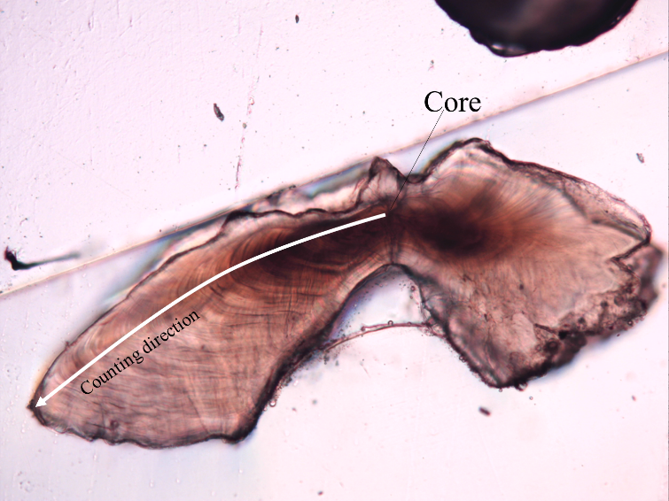
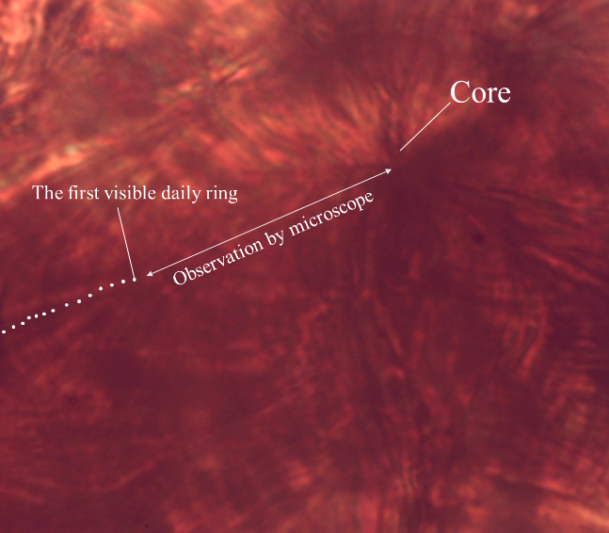
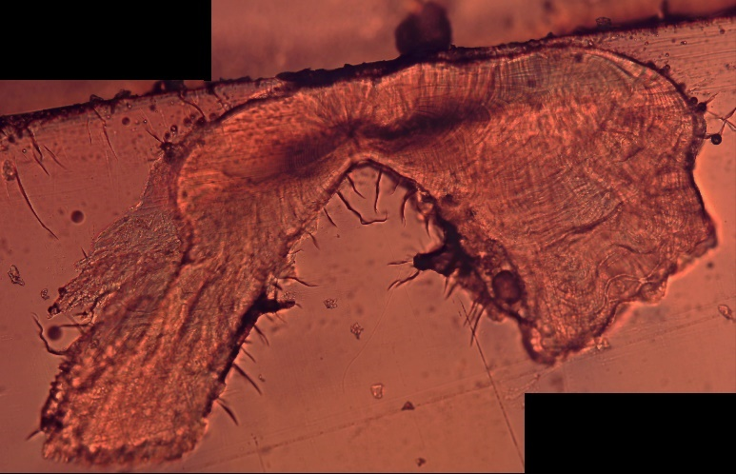
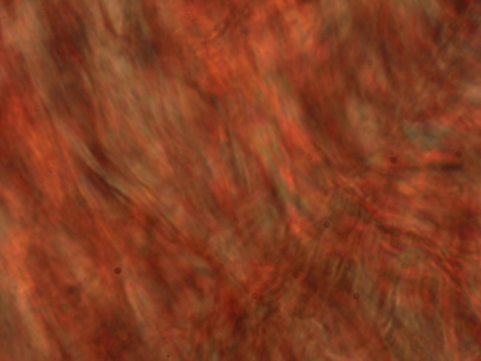
Figures
a
b
c
d
Fig. 1 a: Counting direction; b: Magnified view of the area around the core; c: Otolith with a well-developed, inflected edge; d: Magnified view of the otolith inflection area.
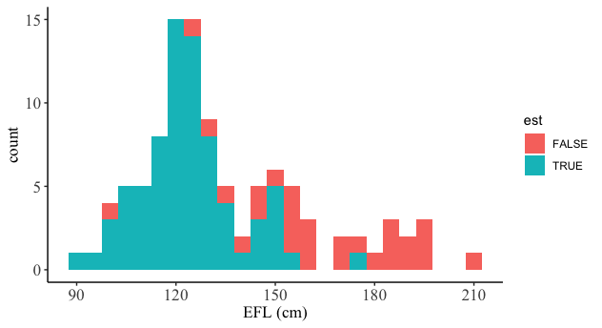
Fig. 2 Eye-fork-length (EFL) composition of otolith samples. Light blue and red indicate samples with estimable and non-estimable daily age, respectively.
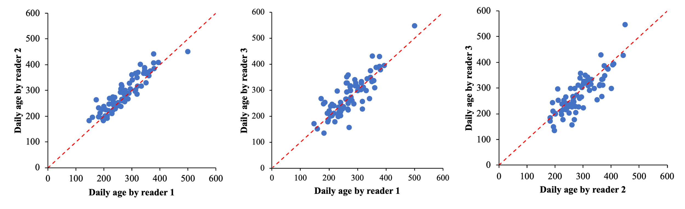
Fig. 3 Comparison of daily age estimates among readers. Red lines indicates the 45° line.
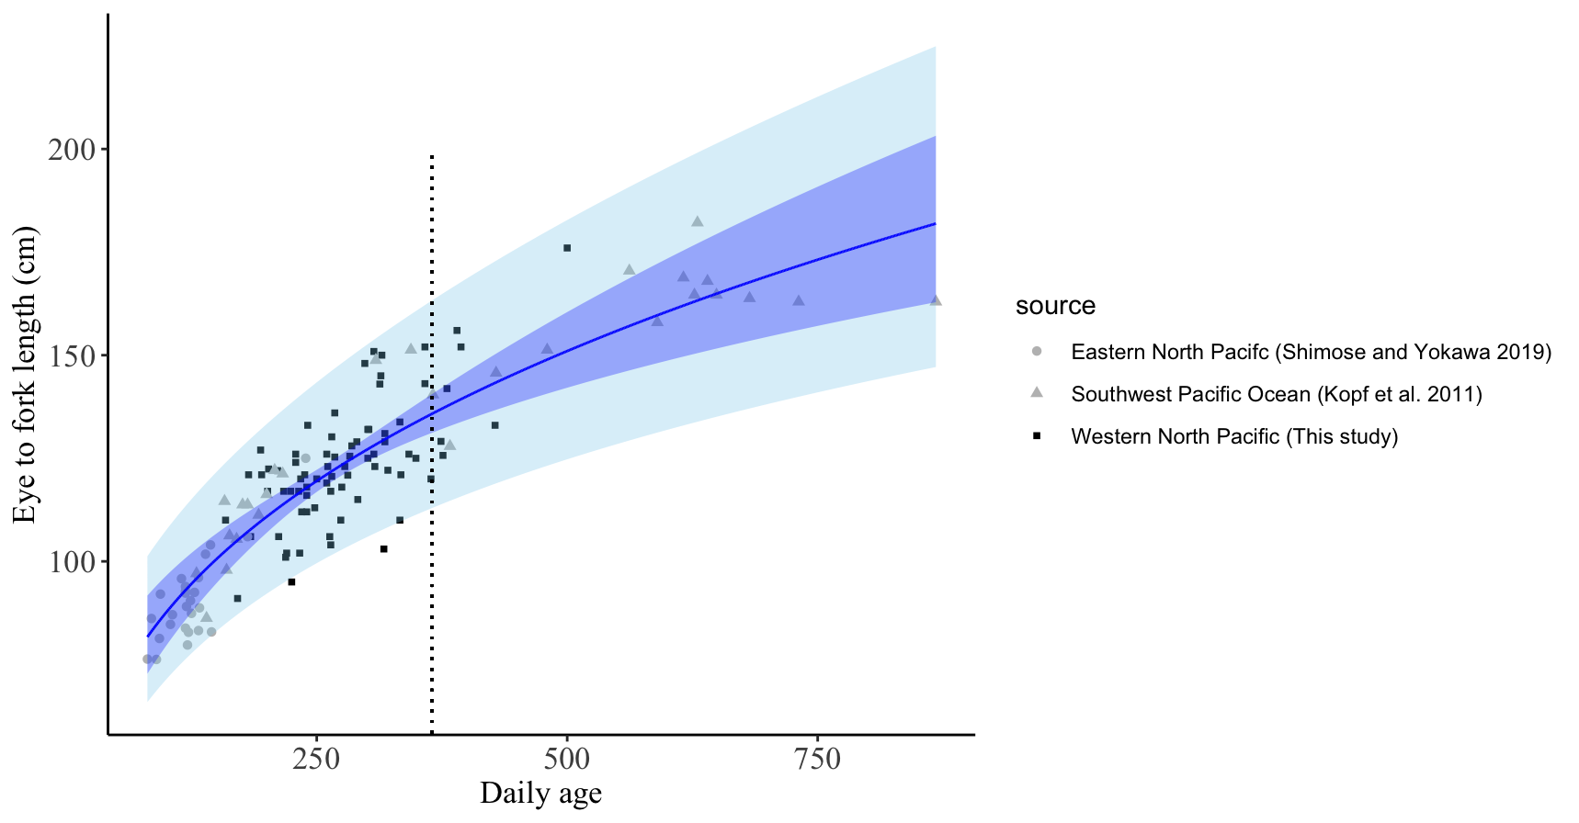

Fig. 4 Early growth based on otolith daily age results. Blue and light blue bands represent 95% confidence and prediction intervals, respectively. The vertical dotted line indicates 365 days of age.

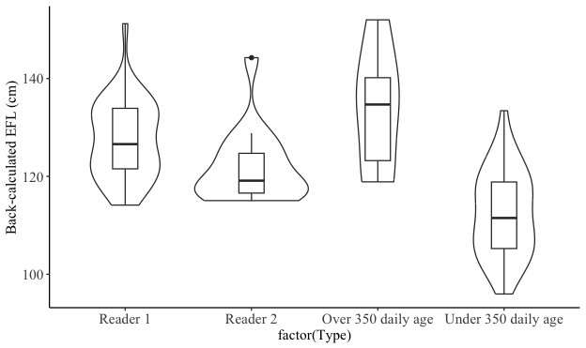
Fig. 5 Comparison of back-calculated eye-fork-length (EFL) at the first annulus in one-year-old individuals between readers (two violine plots on the left). The two violin plots on the right show the distribution of back-calculated EFL for the outermost annulus in samples with otolith daily ages greater than 350 days and less than 350 days.
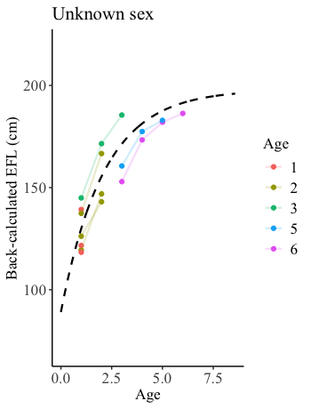
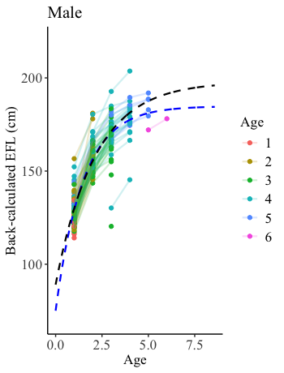
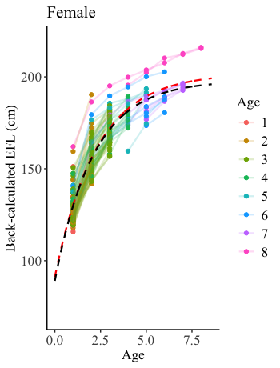

Fig. 6 Back-calculated eye-fork-length (EFL) for each sample and growth curves based on the present studies. The black, red and blue broken lines represent the models for all samples, females, and males, respectively. The filled circles and solid lines represent age-specific EFL estimated by back calculation.

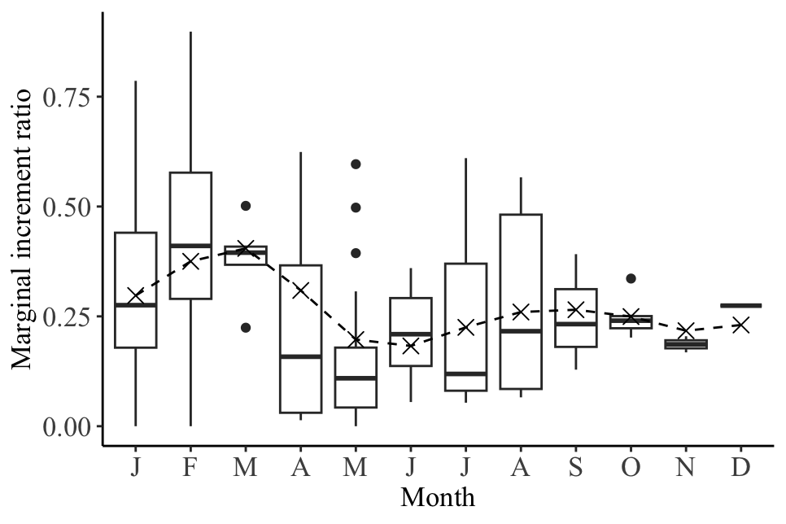
Fig. 7 Monthly trends in marginal increment ratio. Cross points and broken line represent the two-month moving average and the monthly trend, respectively.
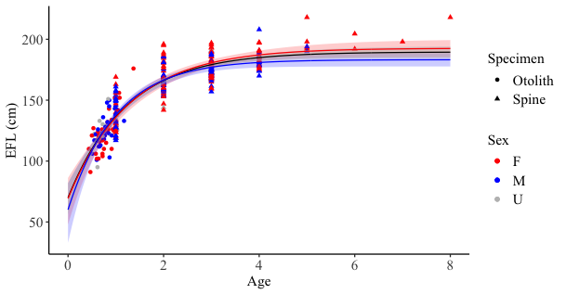
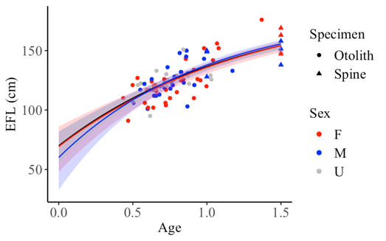

Fig. 8 Estimated growth curves based on age and measured eye-fork-length (EFL). The ribbons represent the 95% confidence intervals for each model.

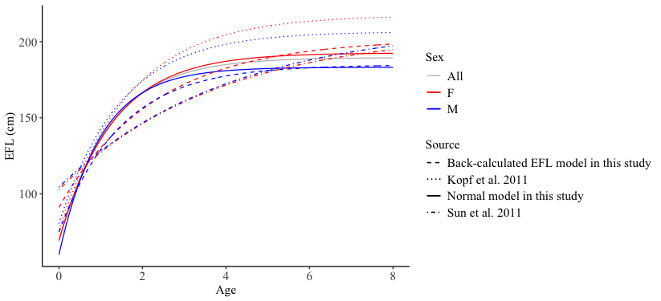
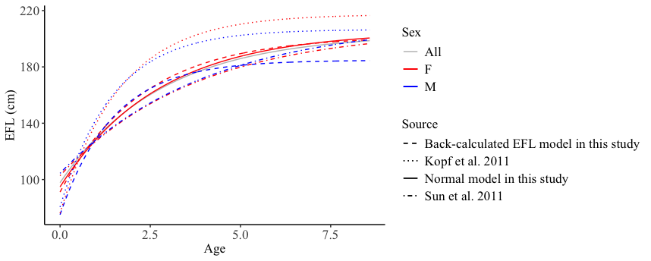




Fig. 9 Comparison of sex-specific growth curves among several studies. The curves from previous studies were converted from lower-jaw-fork-length to eye-fork-length (EFL) using the transformation formula provided by Kopf et al. (2011).

